Unsupervised Detection of Background and Moving Cars

Yongning Wu, Xiao Ling

Problem Statement

Background subtraction, also known as Foreground Detection is typically the first step before more in-depth object recognition.

In this simplified setting, we assume that

1. A fixed camera facing some traffic
2. Car is the main moving part.

SAMPLE FIGURE (before and after)

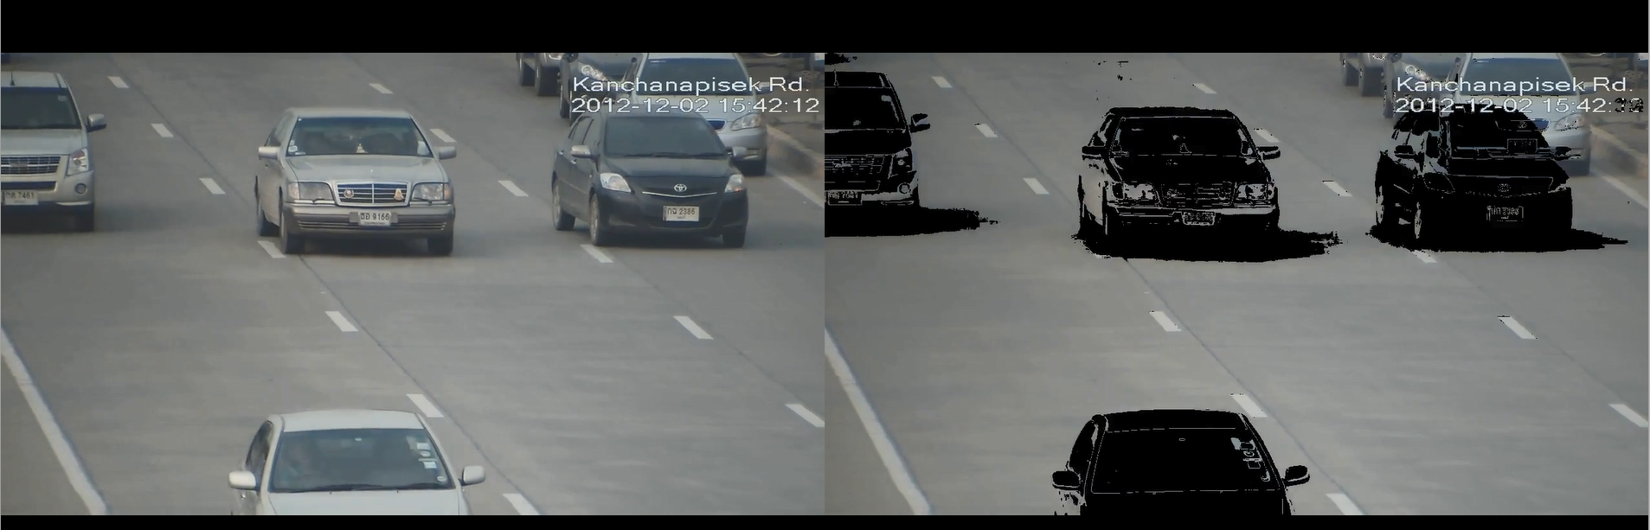

Main Steps

1. extract data file from video
2. converge on background
3. annotate frames

Method

EM algorithm is the main method used to iteratively improve the estimation of unobserved background. We assume there is a background predictor BP.

* E-step: for each pixel on each frame, predict the likelihood of background with BP.
* M-step: update background estimation by weighted average of all frame pixels.

SAMPLE FIGURE (show result after each iteration)

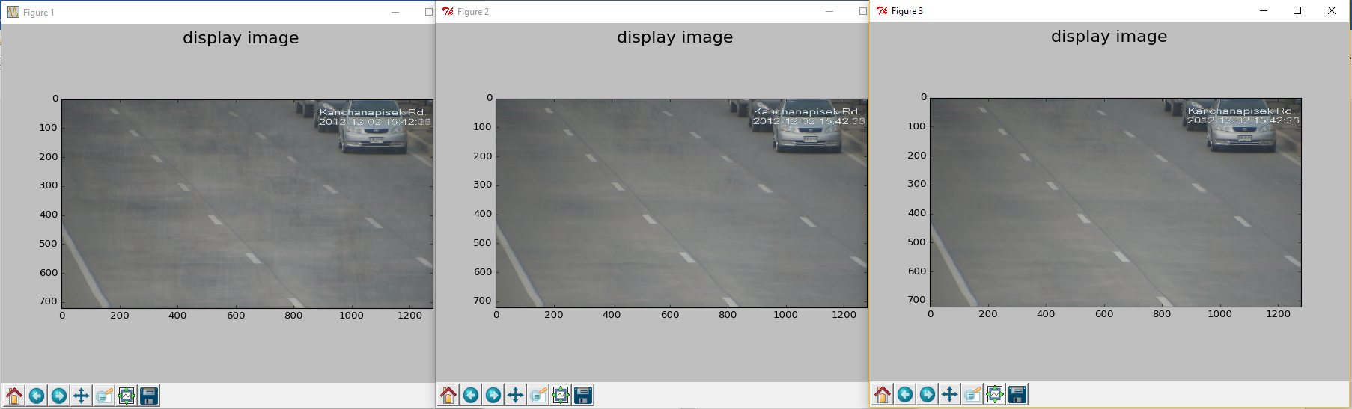

Background Initialization

1. A simple version is to take unweighted average of original frames
   * Can handle most of cases where background pixel occupancy is high
2. A sophisticated version is to apply an external car predictor which only gives a rough mask of the car
   * Better initialization and closer to true background

SAMPLE FIGURE (show external predictor with box in figure)

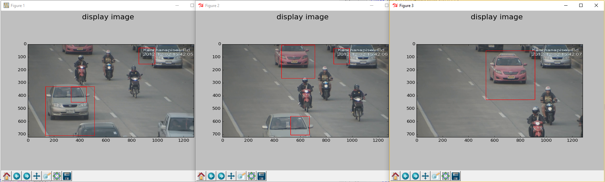

Background Predictor: BP

1. Use Gaussian density function
2. Mean is the weighted average of background
3. Standard deviation starts with high value and tends to decrease with iteration.
4. The prediction will be smoothed in (x, y) dimension.
5. [TODO] further smoothed in time dimension

SAMPLE FIGURE (compare smooth vs non-smooth)

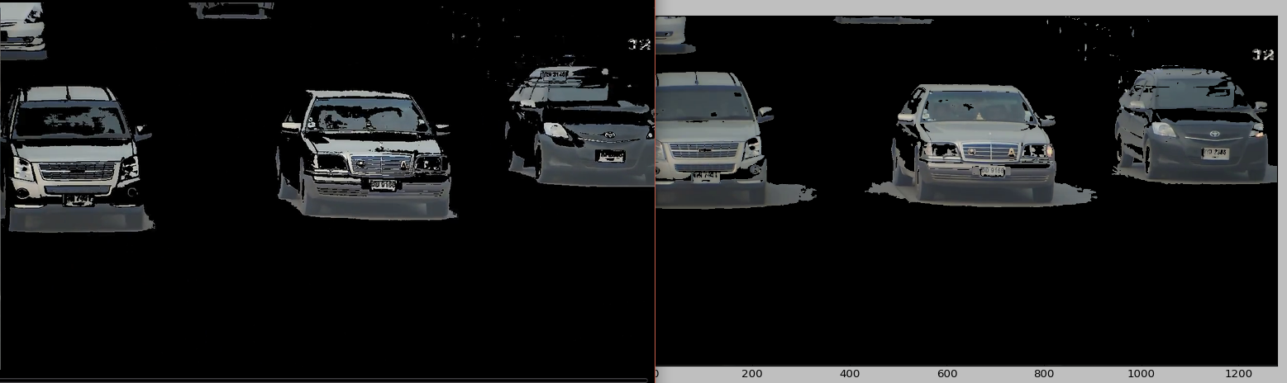

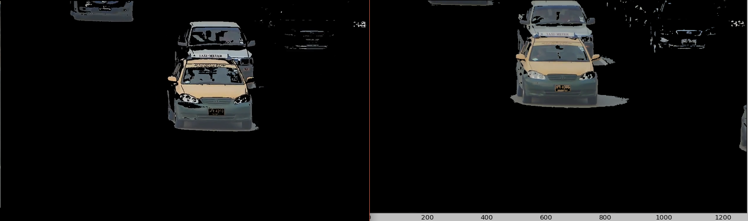

Foreground Annotation

Try to enforce a binary classification on the given frames:

1. Depends on predictor (sigma in Gaussian), threshold
2. Smoothing

SAMPLE FIGURE (show extraction)

Discussion

1. Pixel level alignment to handle camera shaking
2. Better prior initialization
3. Space-temporal smoothing and long time range background update.